**Test plan:**

|  |  |  |  |
| --- | --- | --- | --- |
| Test ID | Test Name | Criteria for Test Name | Expected Result |
| 1 | Unit Test |  | User must can access and its need to be work smoothly |
| 2 | Integration Test | * comments * Like * Comments reply * send email | This information must need to show in system and it will work properly. |
| 3 | Functional Test | * Submit Alumni student number form | Those Functional tasks should work in the system. |
| 4 | Usability Test | * Navigation Bar * Search option * Dropdown Menu | Make sure those elements add in the perfect place and its work in at the right time. |
| 5 | Security Test | * Authentication of User * Checking of URL * SQL Injection | Secure the system privacy and maintaining the secure payment method. |
| 6 | Browser Compatibility Test | * Google Chrome * Mozilla Firefox * Internet Explorer | It’s should run smoothly in every possible working place. |
| 7 | Responsive Testing | * Phone * tab | The Responsive in every device should be perfect. |

**Test design and Cases:**

**2. Integration Test**

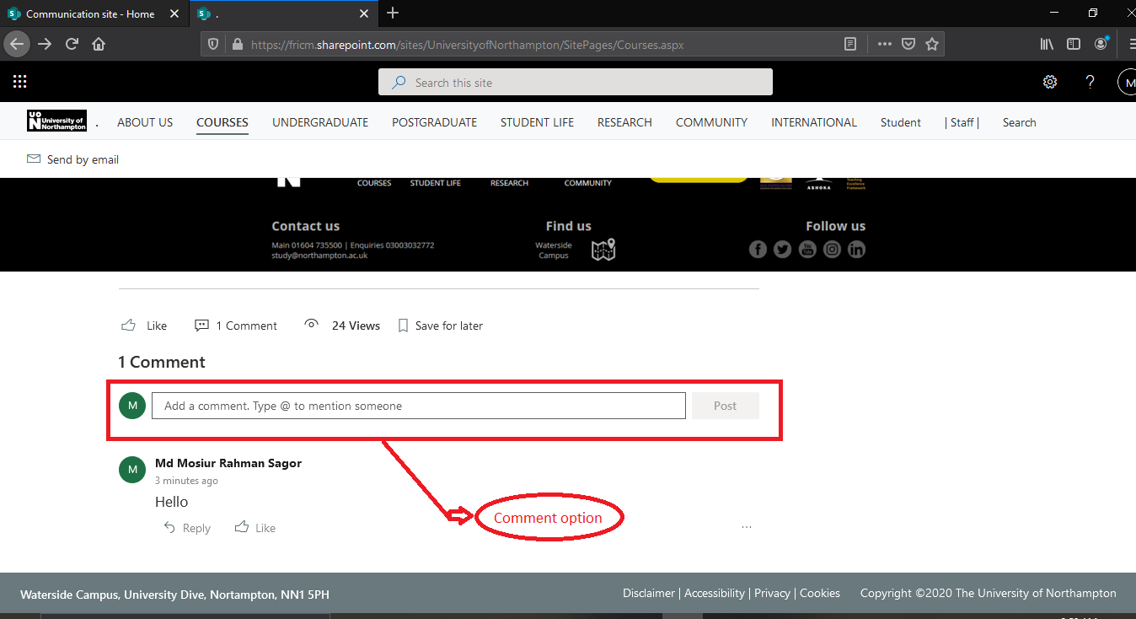

**Figure:**  In comment option post comments.

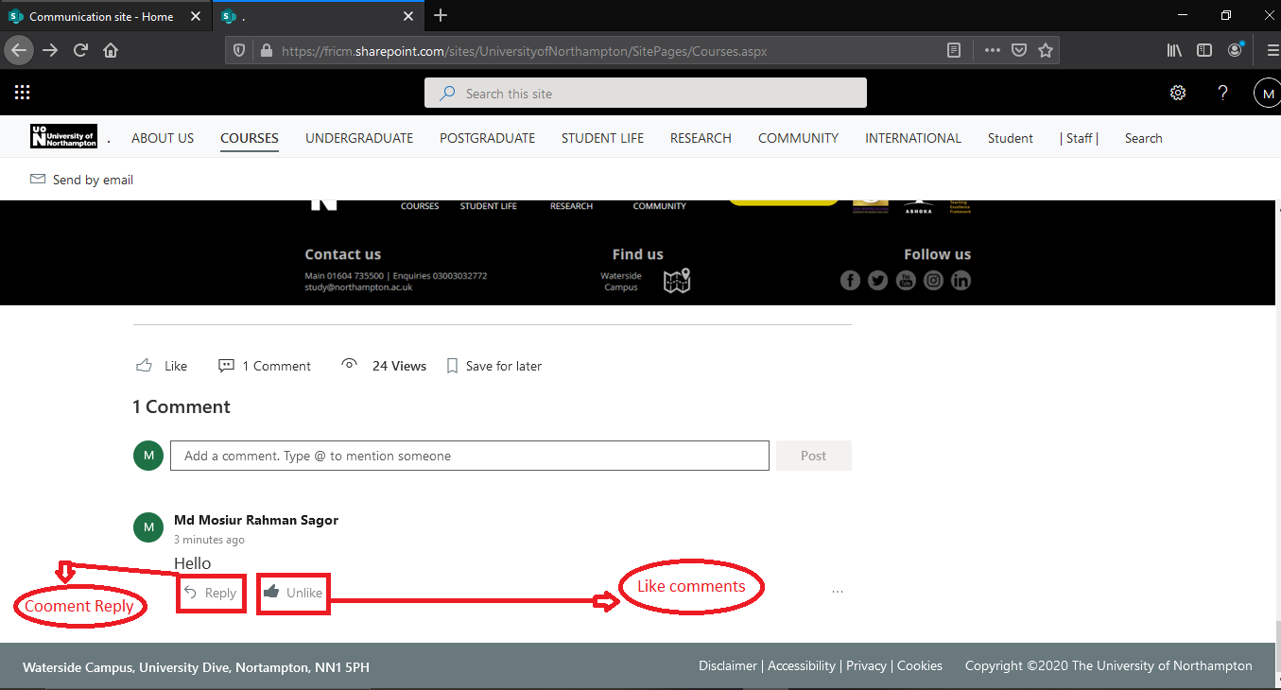

**Figure:**  comment can be like and reply comment.

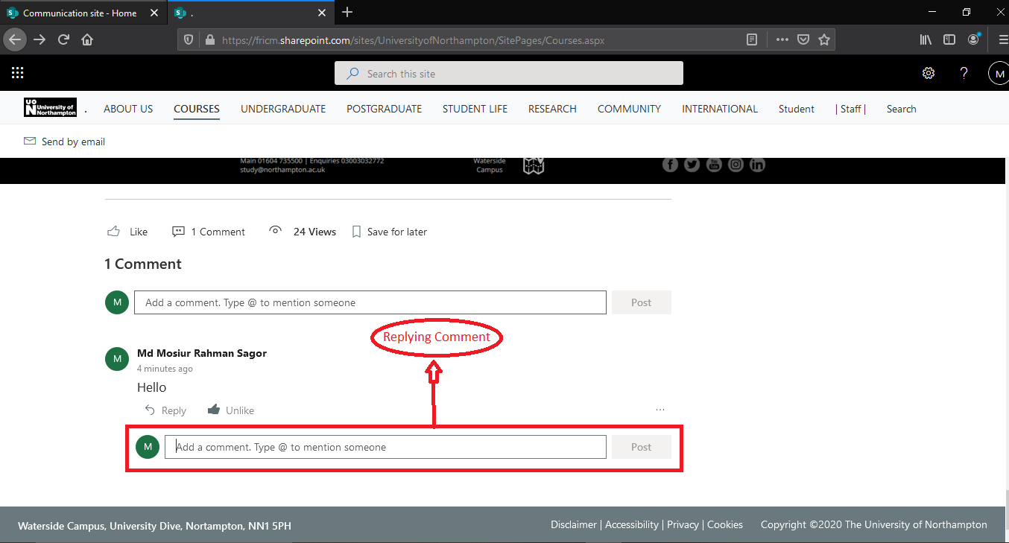

**Figure:**  Comment Reply in reply button.

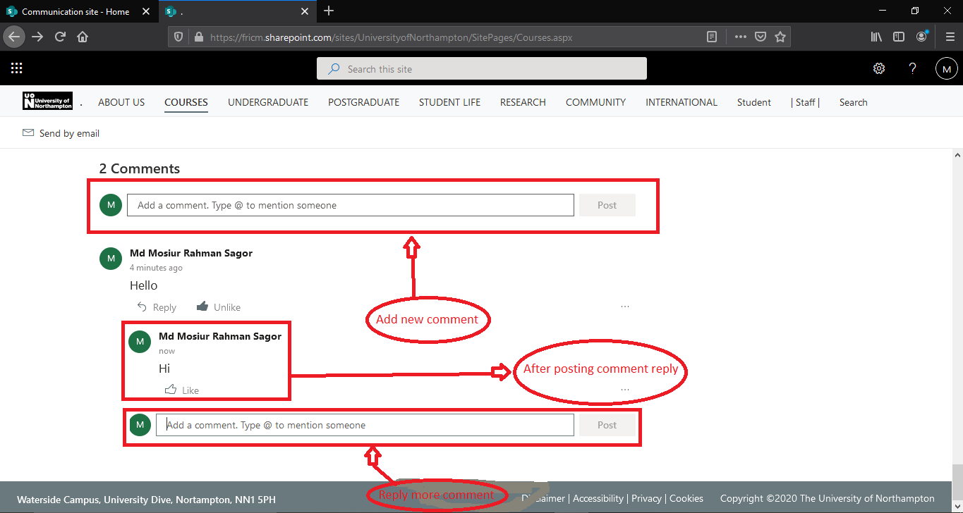

**Figure:**  After reply comment and can add new comment.

|  |  |  |  |  |
| --- | --- | --- | --- | --- |
| **Title** | **Pre-condition** | **Steps of Test** | **Expected Result** | **Actual Result** |
| Replying comments and like in the system | Users must give there opinion and communicate with other | In comment option user can add comment and reply the comments. User can also like other comments | User must comment to communicate with. User also should give their opinion what is like. | Comment and like option has been added and also user can reply other comments. |

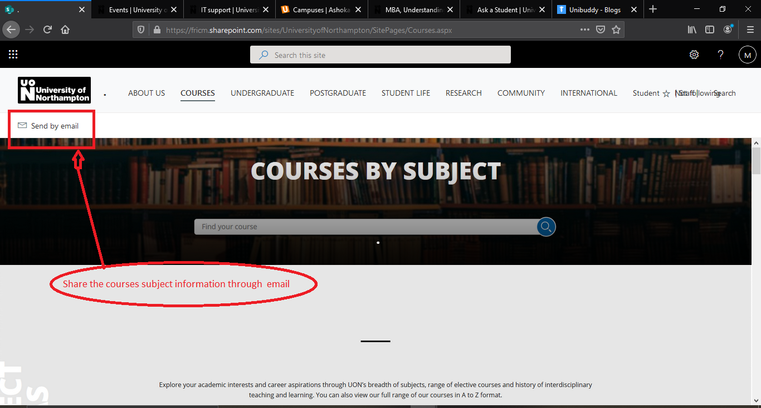

**Figure:**  Click the send by email for send email.

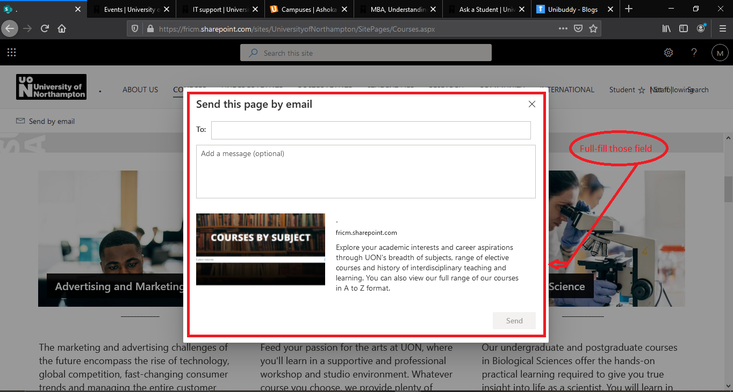

**Figure:**  full-full the entire field.

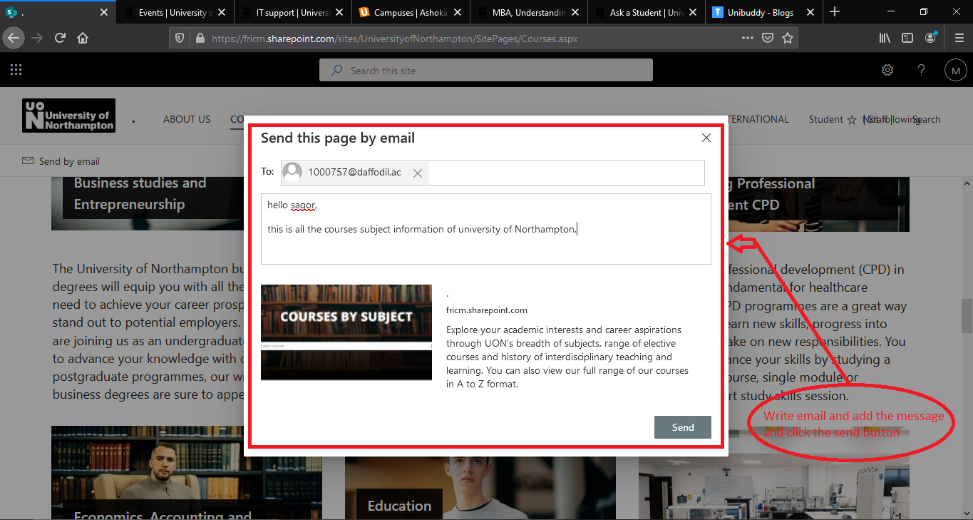

**Figure:**  After full-full the entire fields then click the send button.

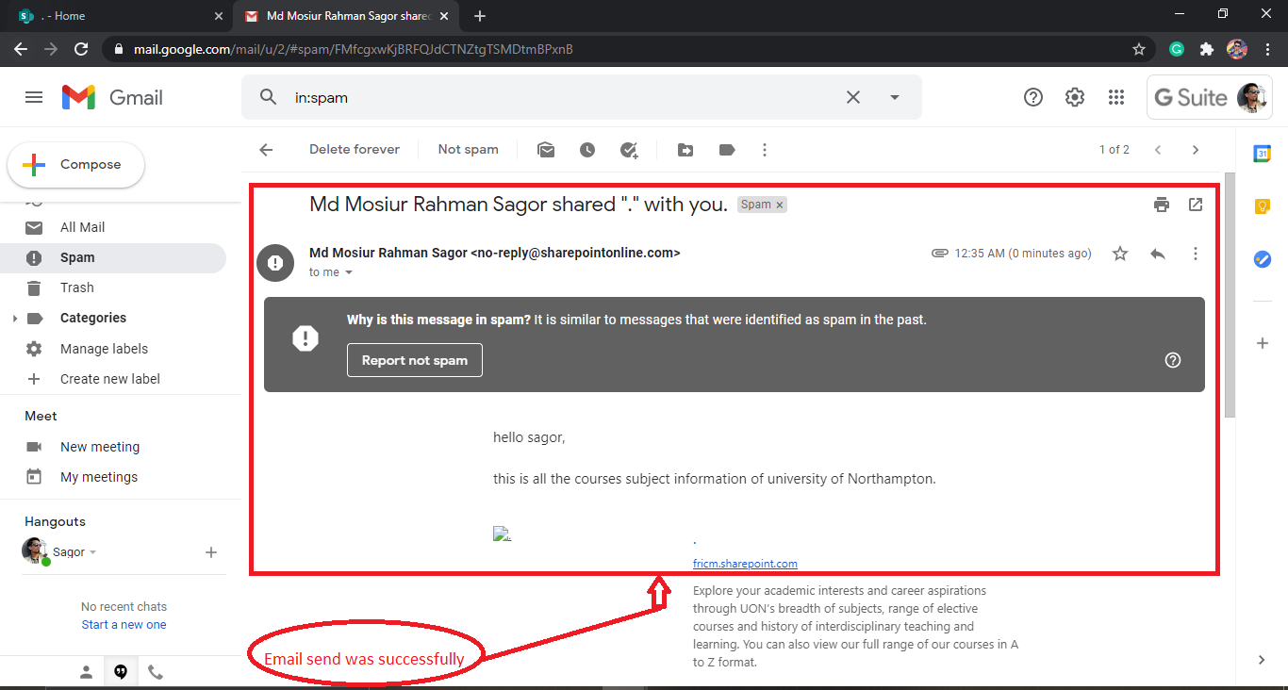

**Figure:**  Email send successfully.

|  |  |  |  |  |
| --- | --- | --- | --- | --- |
| **Title** | **Pre-condition** | **Steps of Test** | **Expected Result** | **Actual Result** |
| Send by email | Users must share the information by the email | In email send option user share the information with other by email | Users can send information through email. | The share information has been found in email inbox. |

**3. Functional Test**

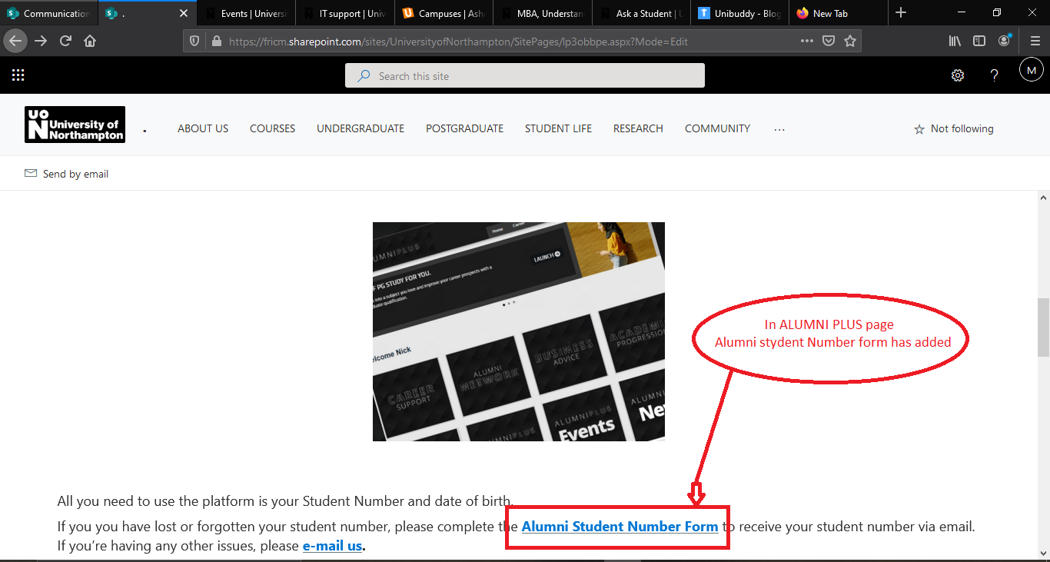

**Figure:**  Click the Alumni student number form

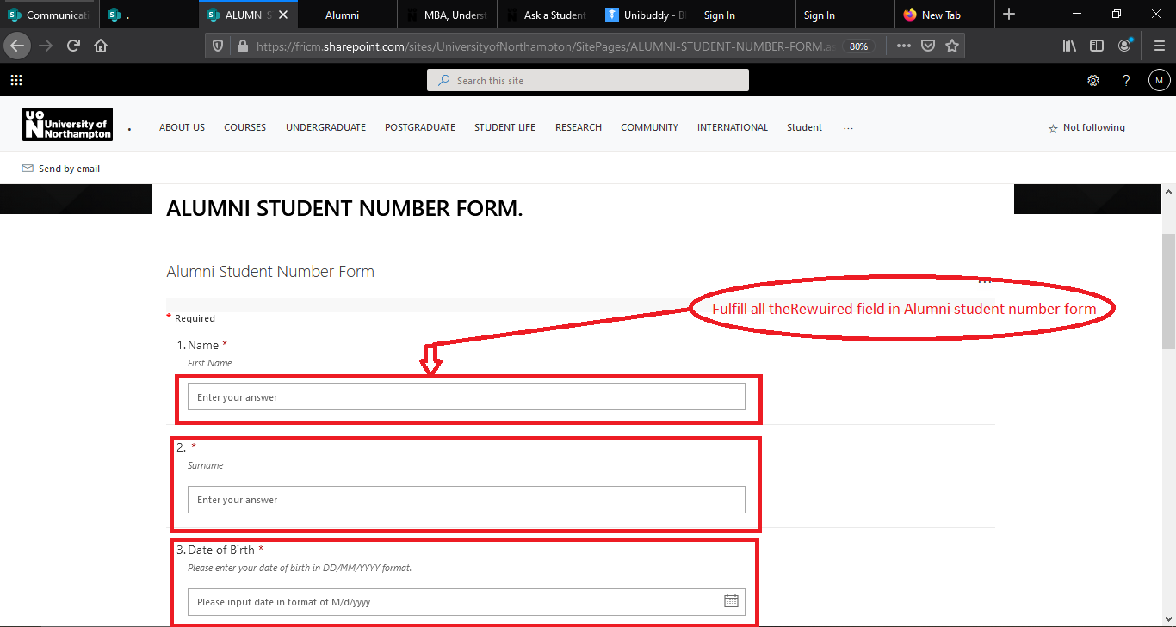

**Figure:**  Fulfill all the Requirements form.

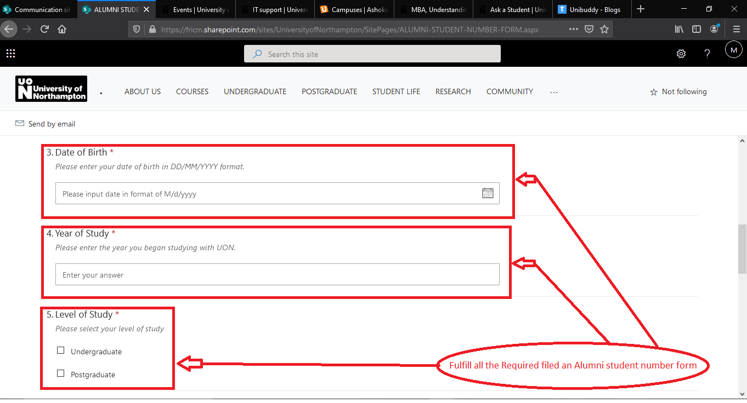

**Figure:**  Fulfill all the Requirements form.

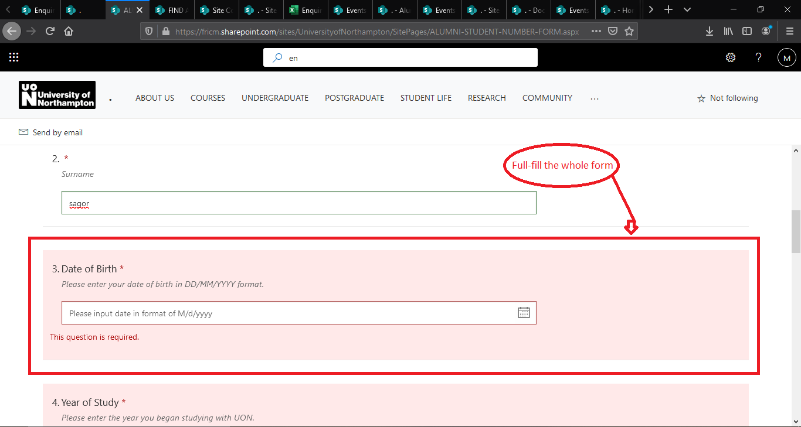

**Figure:**  Without fulfill the whole form .

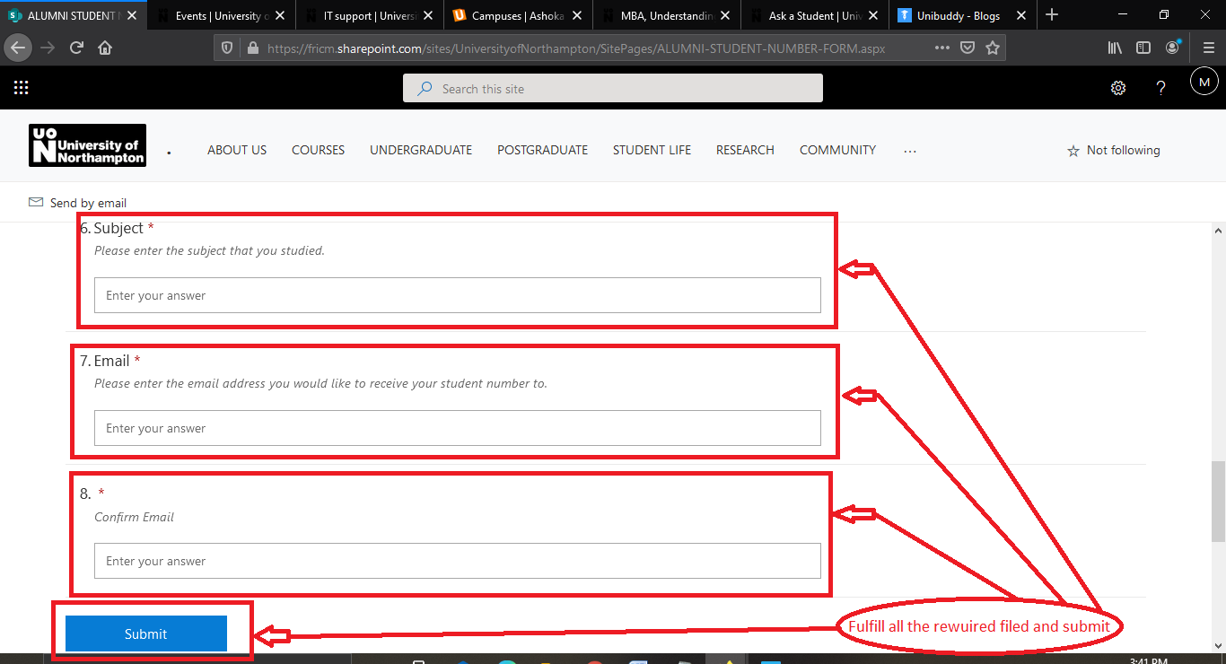

**Figure:**  Fulfill all the Requirements form and Click the submit button.

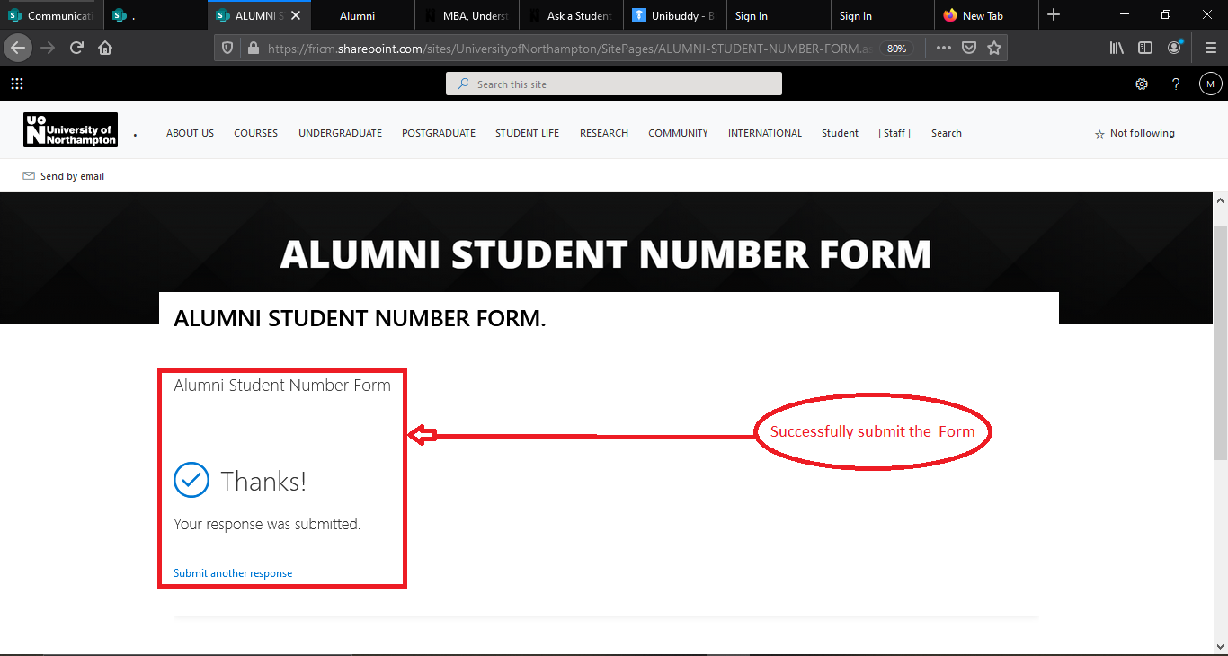

**Figure:**  Successfully submit the form has been show.

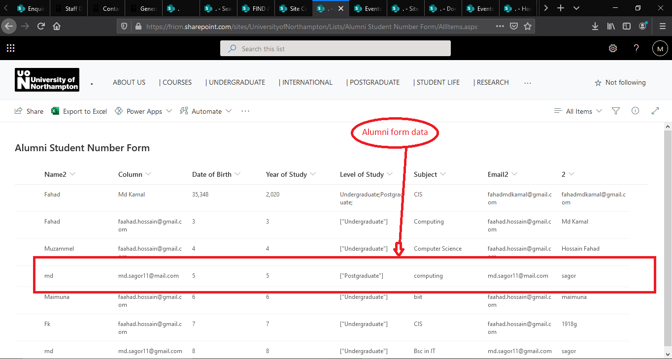

**Figure:**  The alumni student number form data has been save.

|  |  |  |  |  |
| --- | --- | --- | --- | --- |
| **Title** | **Pre-condition** | **Steps of Test** | **Expected Result** | **Actual Result** |
| Submit Alumni student number form. | Process and confirm the submission. | Fulfill the form and click the submit button. | The form should be Successfully accepted. | Conformation of accepted the form. |

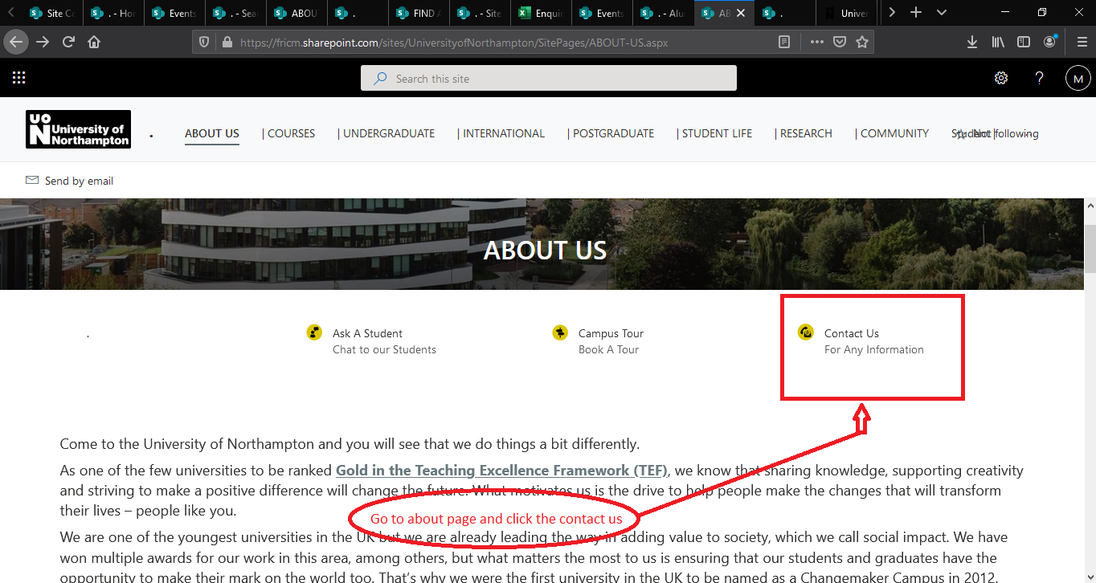

**Figure:**  Go to about us page and click the contact us.

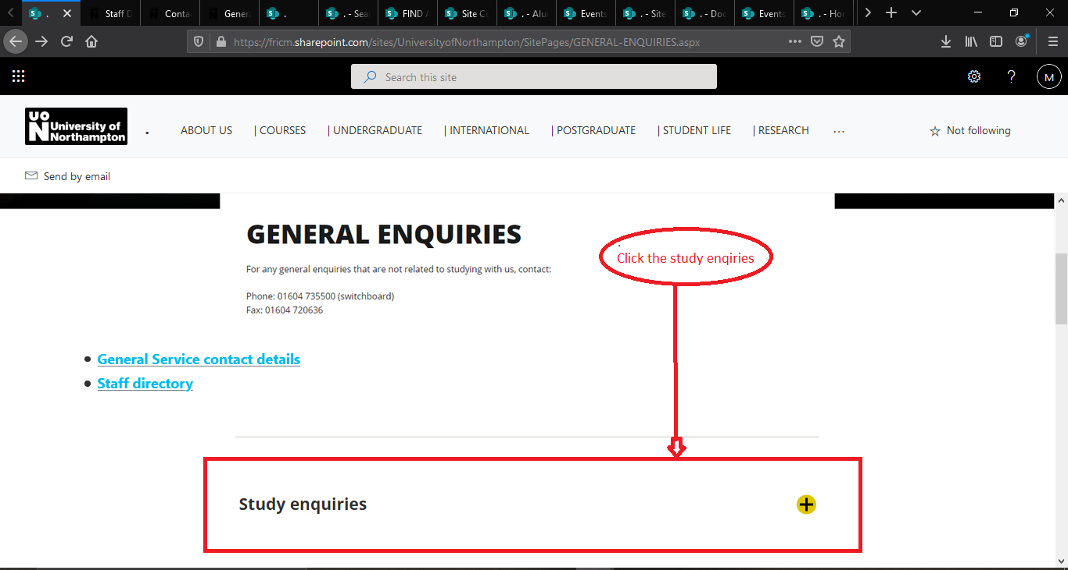

**Figure:**  Now click the study enquiries.

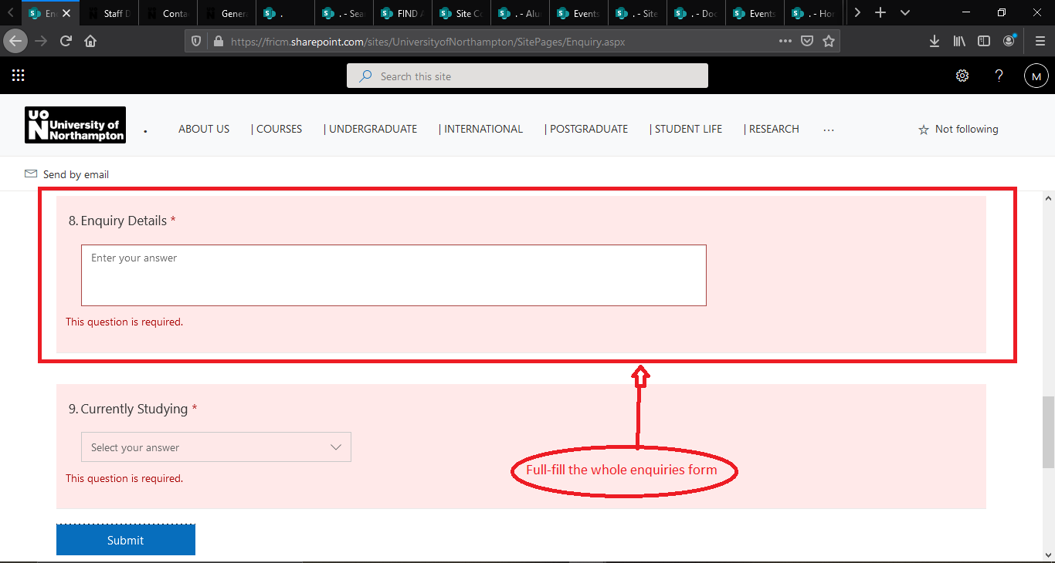

**Figure:**  Fulfill all the Requirements form and Click the submit button.

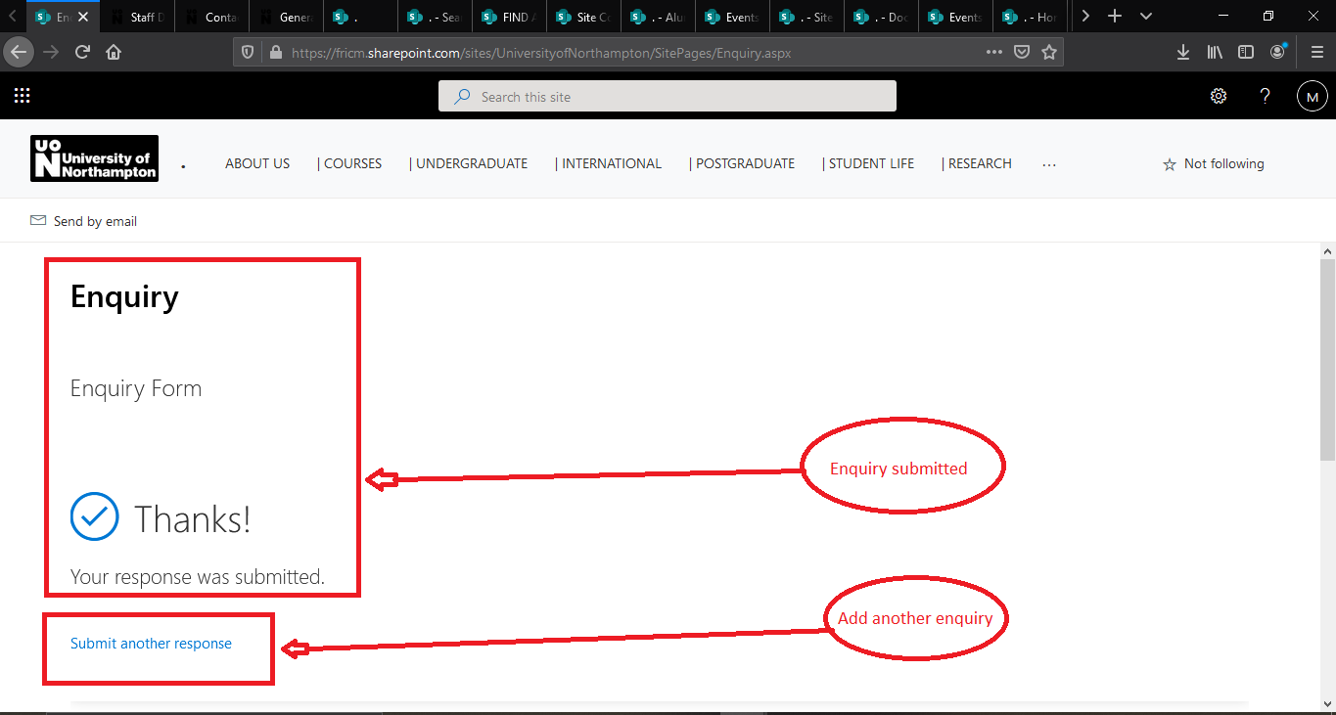

**Figure:**  Successfully submit the form and can submit another enquiry.

|  |  |  |  |  |
| --- | --- | --- | --- | --- |
| **Title** | **Pre-condition** | **Steps of Test** | **Expected Result** | **Actual Result** |
| Study enquiries | Process and confirm the submission. | Fulfill the form and click the submit button. | Fulfill the form this should be Successfully accepted. | Conformation of accepted the form. |

**4. Usability Test**

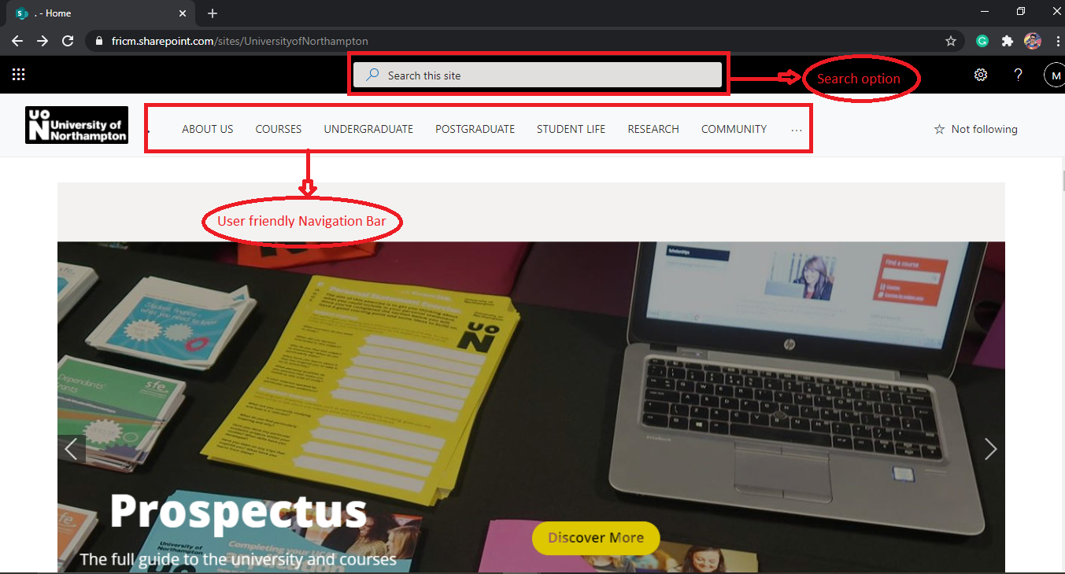

**Figure:**  User-friendly navigation Bar and search option

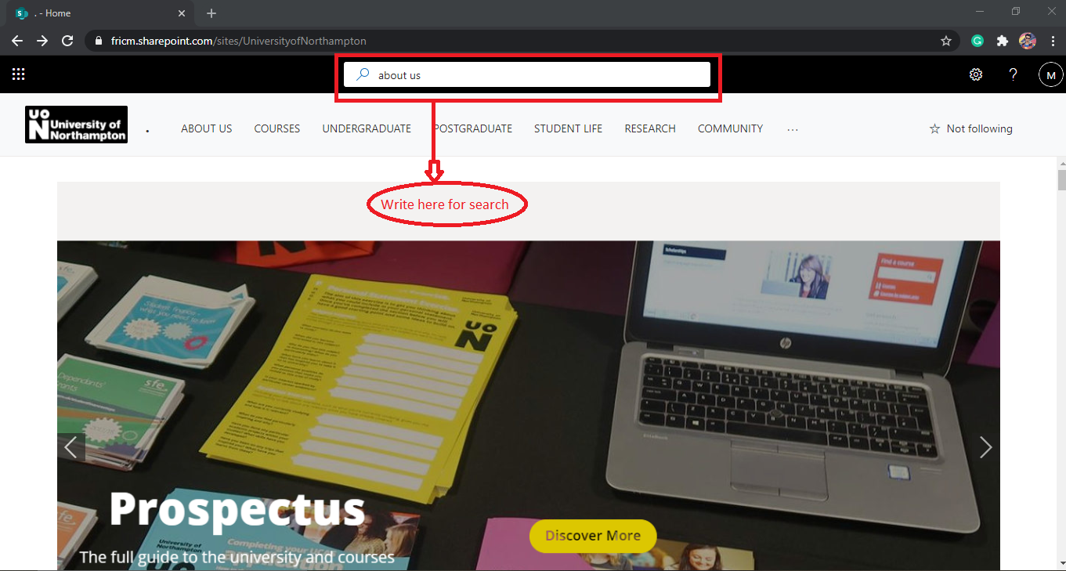

**Figure:**  In search option search about us page.

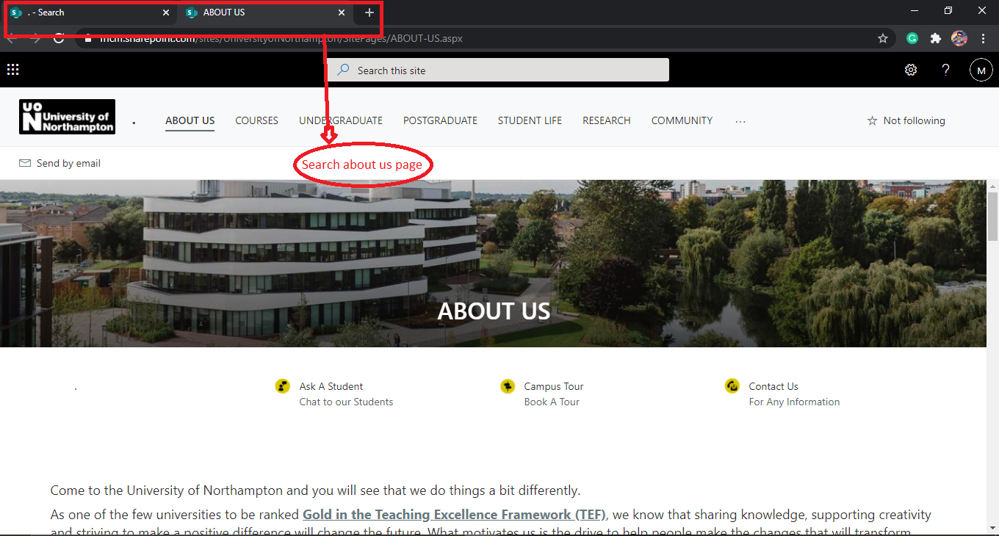

**Figure:**  searching result about us page.

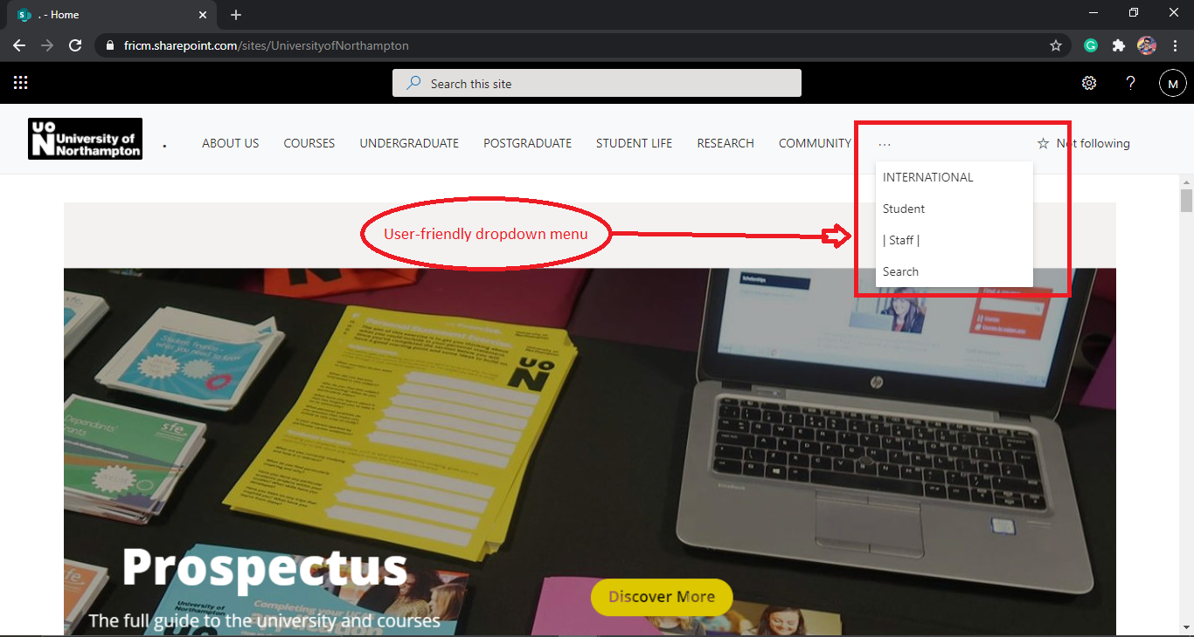

**Figure:**  User-friendly dropdown menu.

|  |  |  |  |  |
| --- | --- | --- | --- | --- |
| **Title** | **Pre-condition** | **Steps of Test** | **Expected Result** | **Actual Result** |
| The usability of the whole system UI. | A user should be use the website as easy as possible ways. | The website has the right place of navigation bar, dropdown menu and for more help a search button has added. | The whole navigation bar, dropdown menu must be in perfectly place. and search button should work. | In usability testing time those feature has been work properly. No usability error was being found. |

**5. Security test**

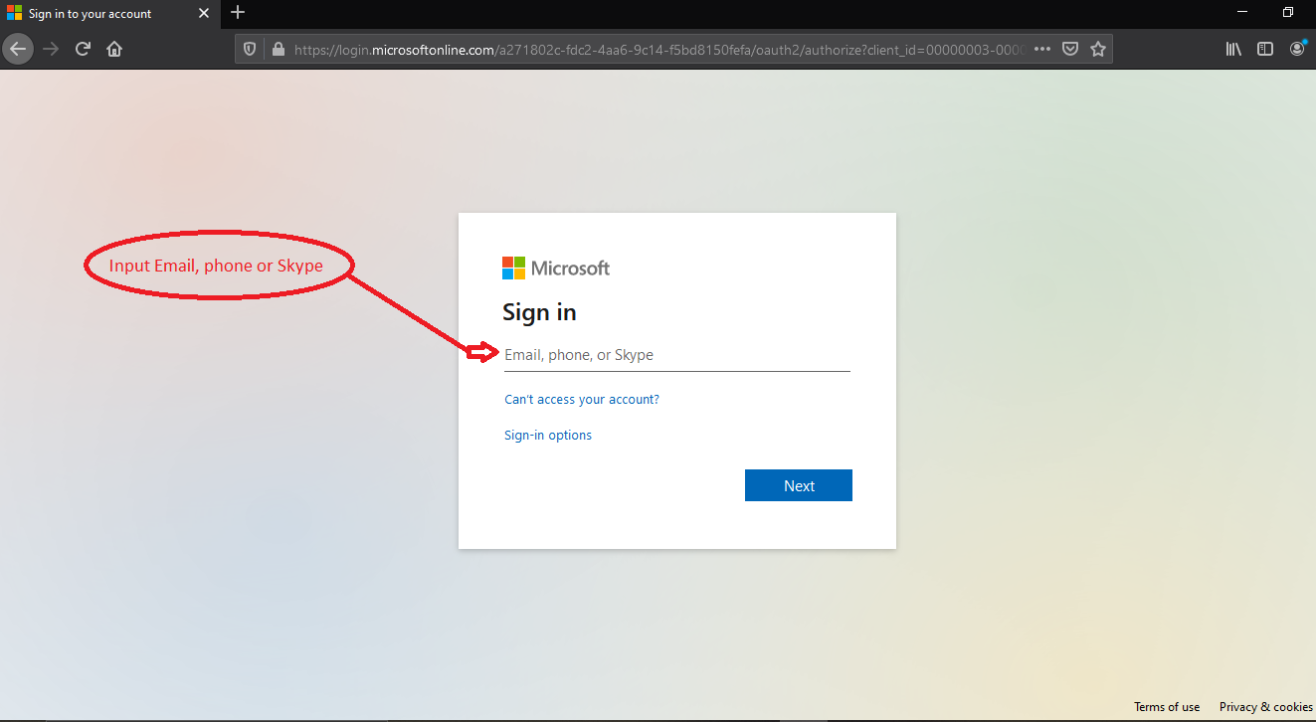

**Figure:** Without genuine email id user will not access the system.

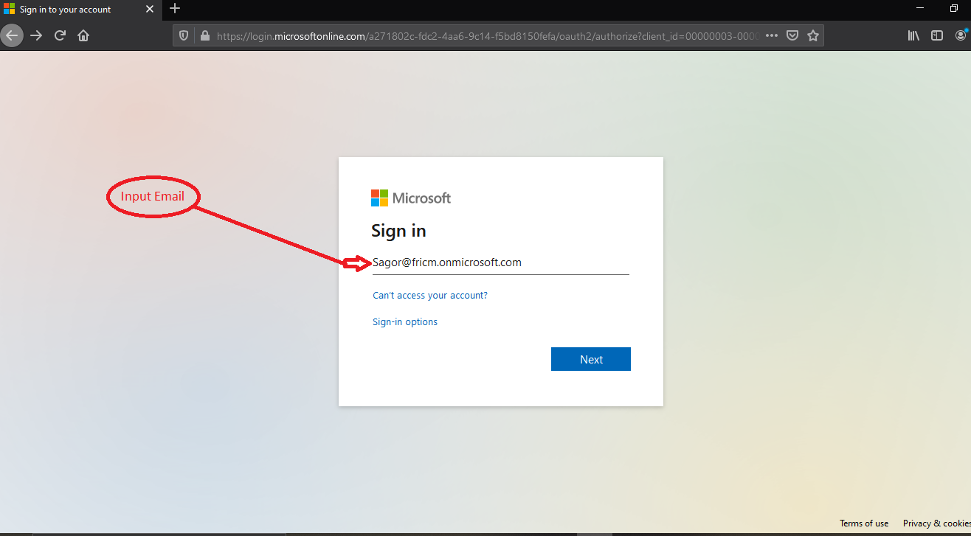

**Figure:** input the genuine email id.

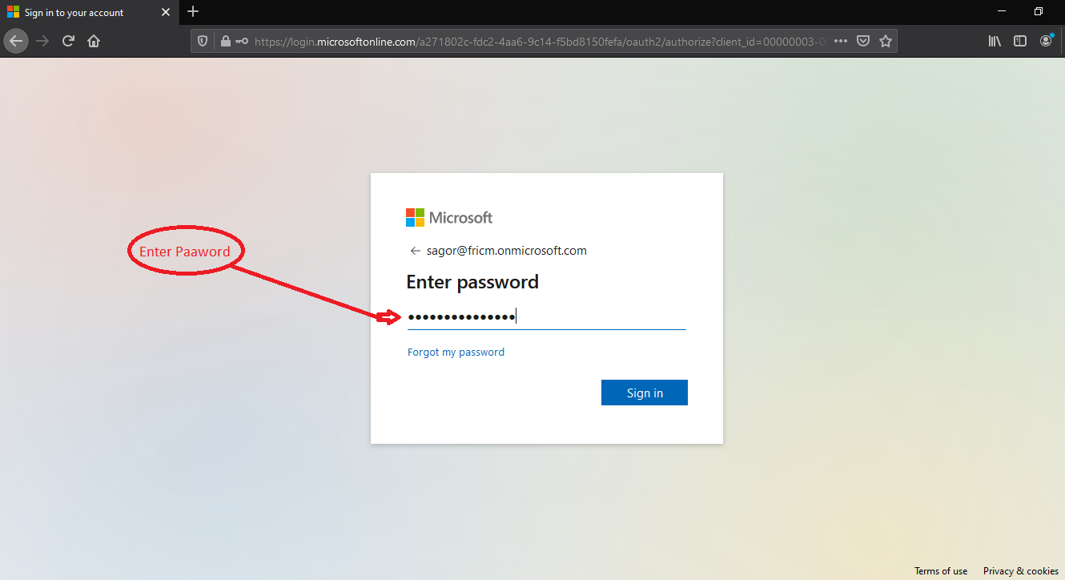

**Figure:** input the genuine password for login.

|  |  |  |  |  |
| --- | --- | --- | --- | --- |
| **Title** | **Pre-condition** | **Steps of Test** | **Expected Result** | **Actual Result** |
| Authentication of User | Users must login for access the system | Login with users genuine Microsoft account | Without genuine Microsoft account it will not login | Successfully login and access the system |

**6. Browser Compatibility Test**

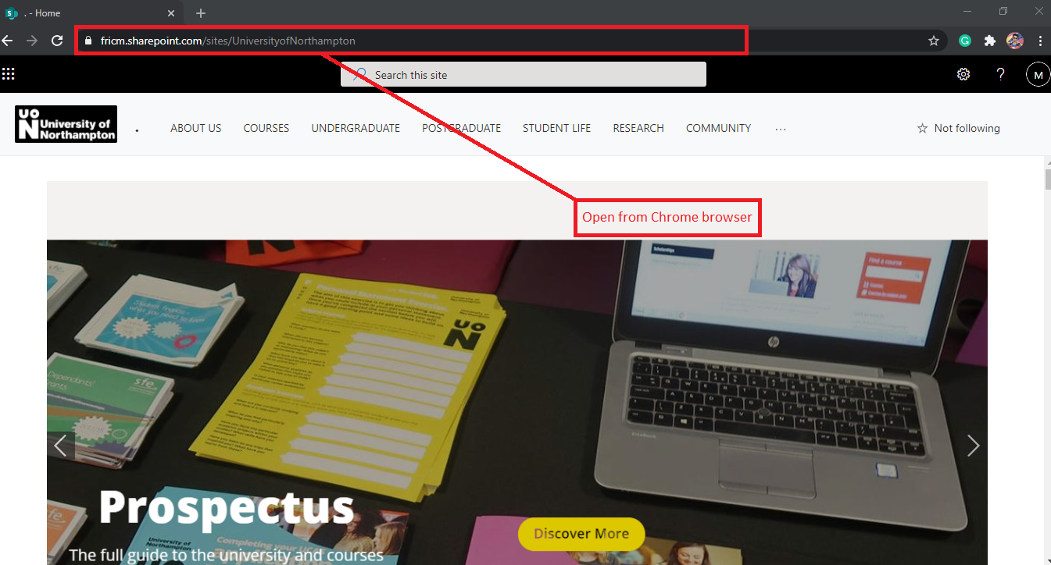

**Figure:** Open from chrome browser

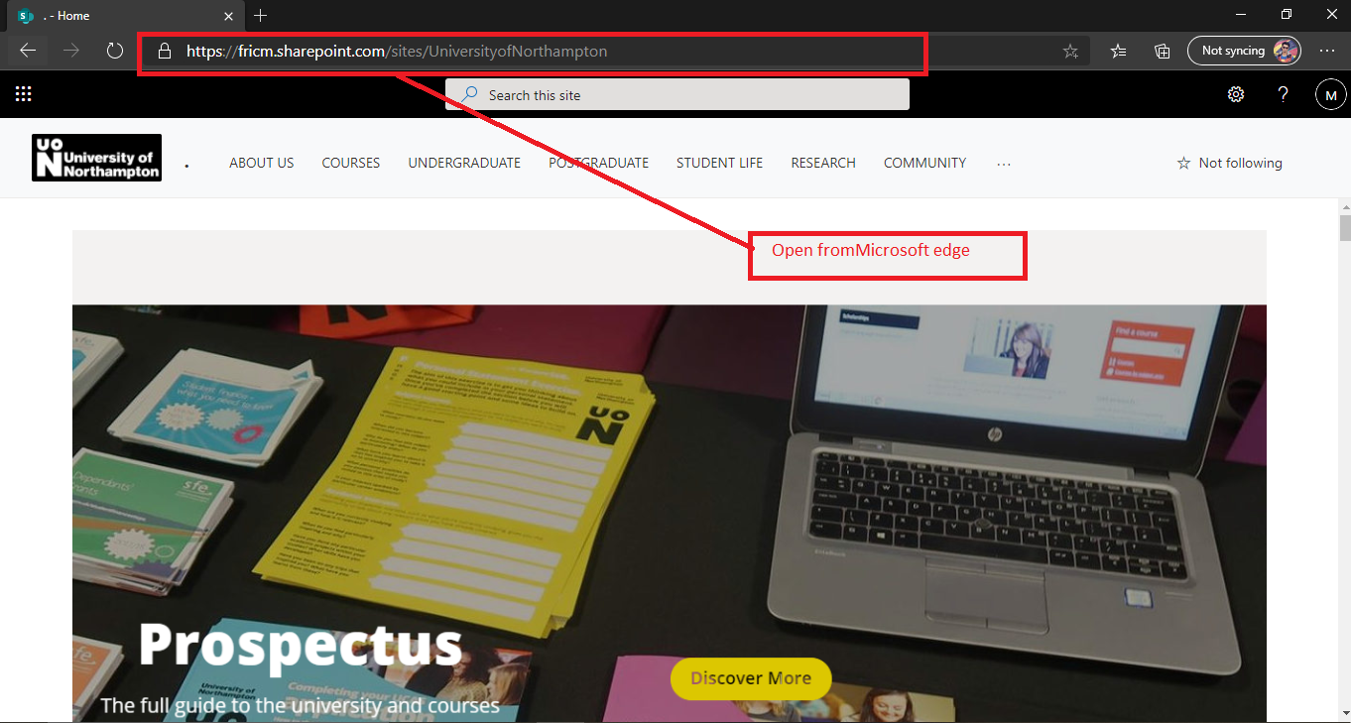

**Figure:** Open from Microsoft edge browser.

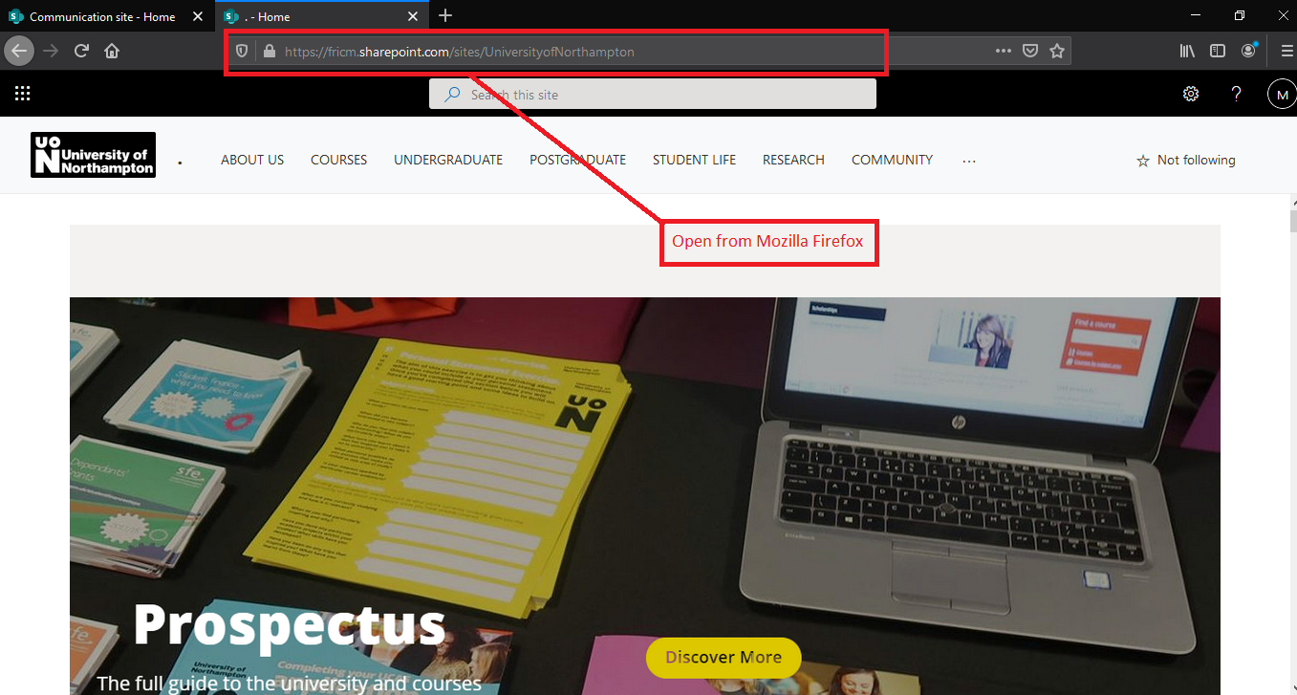

**Figure:** Open from Mozilla Firefox browser.

|  |  |  |  |  |
| --- | --- | --- | --- | --- |
| **Title** | **Pre-condition** | **Steps of Test** | **Expected Result** | **Actual Result** |
| Chose three different browsers for testing. | The website has to open in various different browsers. | At first open all three browser and then evaluate is there any changes by the different browser. | In those three different browsers web site should be same and should run without any problem. | In during testing time the website did not incurred any problem in different browser. |

**7. Responsive Test**

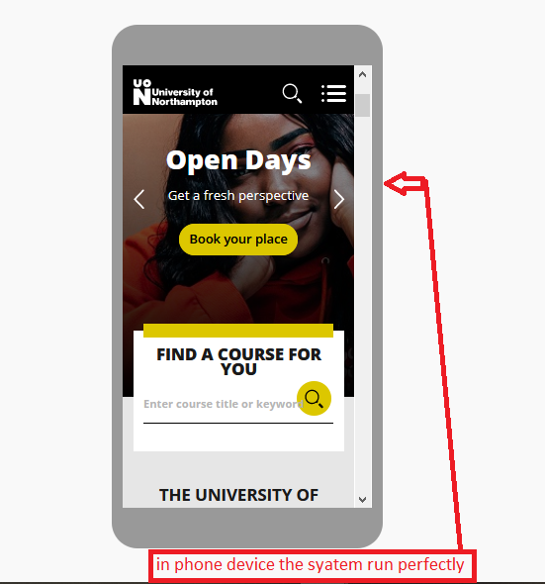

**Figure:** Responsive the system in phone.

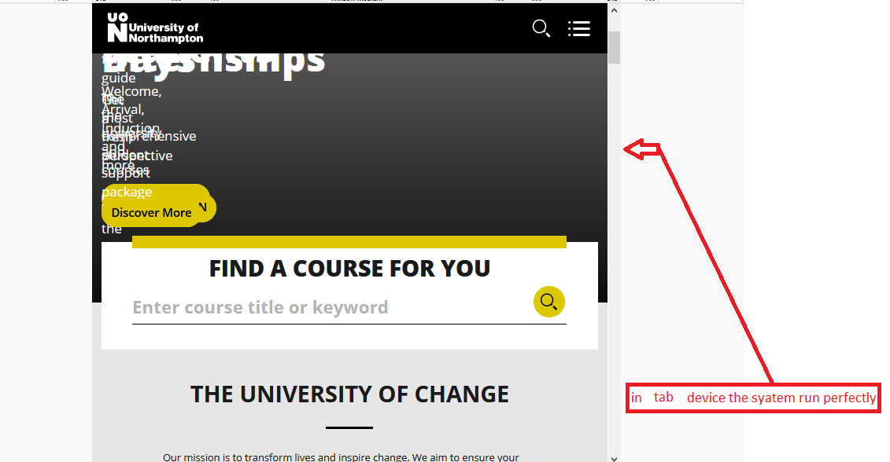

**Figure:** Responsive the system in tab.

|  |  |  |  |  |
| --- | --- | --- | --- | --- |
| **Title** | **Pre-condition** | **Steps of Test** | **Expected Result** | **Actual Result** |
| Select the different device for testing. | The website must show perfectly in mobile view and tab vies screen. | Copy the website link and run the different device and check is there any change in viewing angle. | There shouldn’t be any change in different device viewing angle. | In testing time there was no significant change in different device viewing angle. |

**Test Log:**

|  |  |  |  |  |
| --- | --- | --- | --- | --- |
| Test ID | Name of test | Description | Outcome | Result |
| 1 | Unit test |  |  |  |
| 2 | Integration test | How the Integration has work in the system | The response of the Integration was good. | PASSED |
| 3 | Function Testing | Testing the accuracy of functionality of the system has required | According the requirements the Functions has work perfectly | PASSED |
| 4 | Usability test | Testing how easy a user complete a task in the system | The control of the whole system was easy. | PASSED |
| 5 | Security test | Test is there any security threats have in the system. | The whole system security was been well enough |  |
| 6 | Browser compatibility test | Running the system in different browser platform | The system was perfectly run in every different browser platform | PASSED |
| 7 | Responsive Testing | Test runs the website in different device. | The website should be run perfectly in possible different device. | PASSED |